Update process

Assignment of the firmware/software to the device or device profile triggers the update process. ThingsBoard tracks the progress of the update and persists it to the device attributes.

### **INITIATED state**

Means that the notification about firmware is fetched from queue and pushed to device. Under the hood, ThingsBoard converts notification to the update of the following [shared attributes](https://thingsboard.io/docs/user-guide/attributes/#shared-attributes):

* fw(sf)_title - name of the firmware (software).
* fw(sf)_version - version of the firmware (software).
* fw(sf)_size - size of the firmware (software) file in bytes.
* fw(sf)_checksum - attribute that is used to verify integrity of the received file.
* fw(sf)_checksum_algorithm - the algorithm used to calculate file checksum.

Shared attributes

This type of attributes is available only for Devices. It is similar to the Server-side attributes but has one important difference. The device firmware/application may request the value of the shared attribute(s) or subscribe to the updates of the attribute(s). The devices which communicate over MQTT or other bi-directional communication protocols may subscribe to attribute updates and receive notifications in real-time. The devices which communicate over HTTP or other request-response communication protocols may periodically request the value of shared attribute.

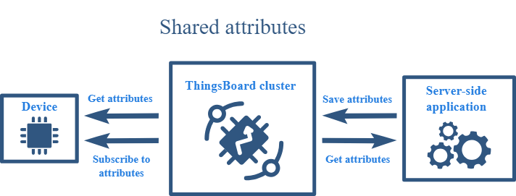

attribute topic name:

* v1/devices/me/attributes
* v1/devices/me/attributes/request/$request_id
* v1/devices/me/attributes/response/+

TOPIC NAME : v1/devices/me/telemetry

{"current_fw_title":"Initial",

"current_fw_version":"0",

"target_fw_title":"COMSURE",

"target_fw_version":"2",

"fw_state":"DOWNLOADING"}

* DOWNLOADING - notification about new firmware/software update was received and device started downloading the update package.
* DOWNLOADED - device completed downloading of the update package.
* VERIFIED - device verified the checksum of the downloaded package.
* UPDATING - device started the firmware/software update. Typically is sent before reboot of the device or restart of the service.
* UPDATED - the firmware was successfully updated to the next version.
* FAILED - checksum wasn’t verified, or the device failed to update. See “Device failed” tab on the Firmware dashboard for more details.

##Request to server for getting firmware info

TOPIC NAME : v1/devices/me/attributes/request/request_id

Payload data : {"sharedKeys": "fw_checksum,fw_checksum_algorithm,fw_size,fw_title,fw_version"}

Response topic name : v1/devices/me/attributes/response/+

Received data : {"shared":{"fw_checksum":"6e15a614a08587039799b016b1be1005ec46a5b9c4a66b4cda81dbee17353827","fw_checksum_algorithm":"SHA256","fw_size":90538,"fw_title":"COMSURE","fw_version":"2"}}

v2/fw/request/request_id/chunk/0

v2/fw/request/1/chunk/0

v2/fw/response/+/chunk/+

host = SERVER_IP_ADDRESS

PORT = 1883

#####Once the firmware/software is updated, ThingsBoard expect the device to send the following telemetry:

{"current_fw_title": "myFirmware", "current_fw_version": "1.2.3", "fw_state": "UPDATED"}

#####If the firmware/software update failed, ThingsBoard expect the device to send the following telemetry:

{"fw_state": "FAILED", "fw_error": "the human readable message about the cause of the error"}